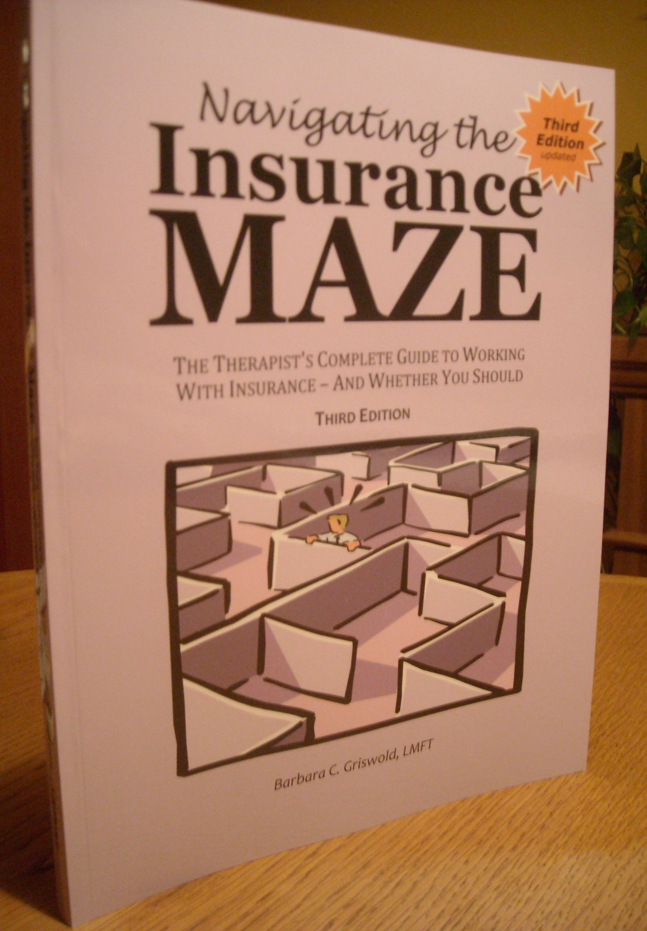
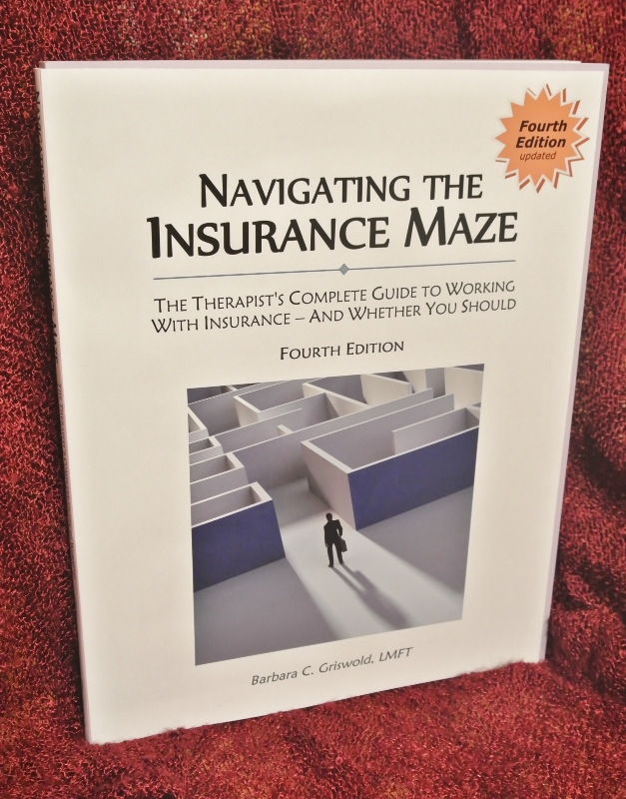
Navigating the
Newly Updated!
Insurance Maze

The Therapist's Complete Guide to Working with Insurance -- And Whether You Should

for therapists nationwide --- NEW 5th EDITION!

It's a simple truth: If you don't take insurance, you're missing out on potential client referrals. And chances are you've lost terrific clients who couldn't afford to continue therapy because you didn’t their accept insurance. But does accepting insurance have to mean mountains of paperwork, compromised confidentiality, steep discounts, and "selling your soul?"

So much is happening on the insurance front – healthcare reform, new CPT codes, and a newly approved claim form. That’s why whether you're an insurance novice or veteran, or don’t accept insurance at all, this is a must-have reference. This practical manual won't gather dust on your bookshelf: You will use it again and again in your practice. In an easy-to-follow format, it answers all your questions about working with employee assistance, managed care, and traditional insurance plans.

Topics include:

◆ Line by line instructions to the new CMS Claim form  Will your treatment be micromanaged?
◆ Strategies to get on “full” plans, and what they look for  Parity laws, HIPAA, and what this means for you
◆ Ways to accept insurance without joining networks  Confidentiality concerns
◆ The 12 crucial questions to ask when checking insurance  How to avoid the most common claim mistakes
◆ The secret to getting more sessions approved  Electronic billing
◆ Getting paid: Tricks to speedy reimbursement  Common billing practices that are insurance fraud
◆ Must you take discounts? Can you negotiate raises?  How to successfully appeal claim denials
◆ The myths and realities of accepting insurance  Is working with insurance right for your practice?

Using a case example, the manual takes you step-by-step through every detail of working with a client's coverage, giving insider tips for dealing with insurance companies. You'll also find many forms you can use with your clients, including a sample appeal letter, a glossary so you'll be fluent in "insurance-speak," and a useful list of resources.

Author Barbara Griswold, LMFT has a private practice in San Jose, California, and has over 20 years experience as a provider for over 15 insurance plans. She lectures around the state about insurance issues, and writes a monthly insurance e-newsletter. She is on the Board of Directors of the California Assn. of Marriage and Family Therapists, and is a past member of the CAMFT State Ethics Committee. Visit her website at www.therinsurancemaze.com to view her workshop schedule, subscribe to her free newsletter, or to set up a consultation if you have insurance questions or problems or want help joining insurance plans.

- - - - - - - - - - - - - - - - - - - - - - - - - - - - - - - - - - - - - - - - - - - - - - - - - - - - - - - - - - - -

Two Easy Ways to Order!

ONLINE: Charge to your credit card or bank account or PayPal account at www.theinsurancemaze.com

MAIL: Send lower portion with a check for $35.98 (includes sales tax and shipping)
Mail check payable to Barbara Griswold, MFT, 4100 Moorpark Ave. #116, San Jose CA 95117

Your Name:_____________________________________________________________________
Mailing Address:_________________________________________________________________
City: _____________________________________ State:__________ Zip:___________________
Phone: (______)________________________ Cell/Other Phone:(_______)__________________
E-Mail Address (please print neatly):_________________________________________________
Confirm E-Mail address: __________________________________________________________

Book promo All forms orders 4.20.14

